EXPERIMENT NO. 5

Understanding of HAL library concept and familiarization of STM32 cube IDE by blinking LED.

Aim

Understanding of HAL library concept and familiarization of STM32 cube IDE by blinking LED.

Objectives
Upon successful completion of this experiment, the student will be able to:
- Navigate and use the STM32CubeIDE development environment effectively.
- Understand the role of STM32CubeMX and the HAL (Hardware Abstraction Layer) library in embedded programming.
- Configure microcontroller peripherals (like GPIO, UART) using graphical interface tools.
- Generate HAL-based initialization code using STM32CubeIDE.
- Build, debug, and upload firmware onto the STM32L476RG microcontroller board.
- Interpret and explain the structure of HAL-generated embedded C code.
- Recognize the difference between low-level register programming and high-level HAL abstraction.

Apparatus / Requirements

Hardware Components
- STM32L476RG Nucleo-64 development board
- USB Micro cable (for programming and power)
- Onboard or external LED (optional if GPIO other than onboard LED used)
- PC or laptop with at least 4 GB RAM

Software Requirements
- STM32CubeIDE
- ST-Link USB Driver (usually auto-installed with STM32CubeIDE)
- Optional: Tera Term / PuTTY / RealTerm (for UART communication)
- Optional: Datasheet and Reference Manual of STM32L476RG

Theory

Introduction to STM32CubeIDE
STM32CubeIDE is an all-in-one development environment provided by STMicroelectronics for embedded development with STM32 microcontrollers. It is built upon the Eclipse IDE framework and integrates the STM32CubeMX graphical configuration tool. STM32CubeIDE supports code generation, code compilation, real-time debugging, and direct flashing of firmware into STM32 microcontrollers via ST-Link.
STM32CubeIDE simplifies embedded system development by offering a seamless workflow: developers can configure MCU peripherals graphically (e.g., timers, GPIOs, UART, ADC), generate initialization code automatically, write application logic, and upload it directly to the target hardware. This makes it ideal for both beginners and professionals, as it reduces the learning curve associated with complex low-level embedded programming.
STM32CubeIDE is an all-in-one development tool that integrates:
- STM32CubeMX: A graphical configuration tool for peripheral setup.
- Eclipse-based IDE: For writing, compiling, and debugging C code.
- Toolchain Integration: Based on GCC (GNU Compiler Collection).
- ST-Link Debugging Support: Enables live debugging with breakpoints and peripheral monitoring.
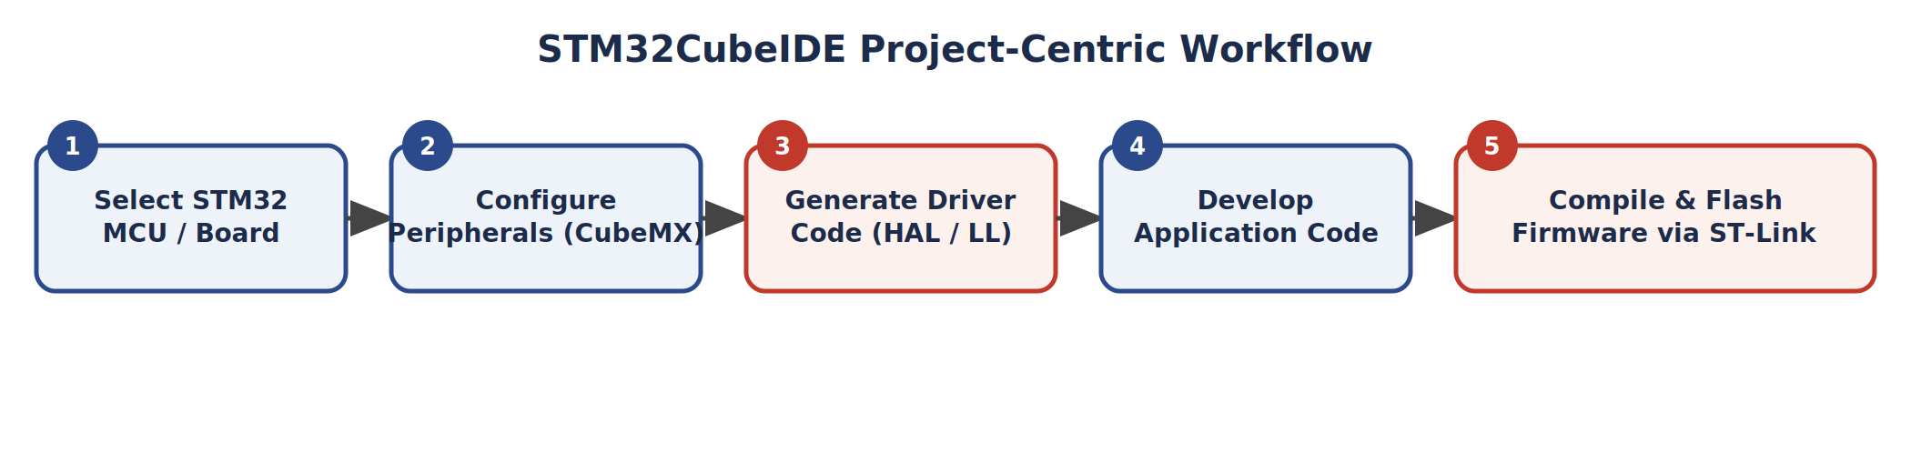

Project Structure in STM32CubeIDE (HAL-based)
Once code is generated, the project will include:
- main.c — Entry point; contains main() function.
- gpio.c / gpio.h — Contains HAL initialization for GPIO.
- stm32l4xx_hal_conf.h — HAL config file with macro definitions.
- startup_stm32l4xx.s — Assembly startup code.
- system_stm32l4xx.c — System clock configuration.
- Drivers/ — Contains core and HAL driver code.
The generated functions include:
- MX_GPIO_Init() — Initializes GPIOs as per CubeMX settings.
- HAL_Init() — Initializes the HAL library.
- SystemClock_Config() — Configures the system clock.

Hardware Abstraction Layer (HAL)
The HAL (Hardware Abstraction Layer) is a driver library provided by STMicroelectronics that simplifies the interaction between the application code and the low-level hardware registers of the STM32 microcontroller. HAL provides a high-level, API-based interface for initializing and using peripherals. Rather than writing direct register-level code (which can be time-consuming, error-prone, and difficult to port), HAL allows developers to write intuitive and readable code to control peripherals such as GPIOs, UART, I2C, SPI, timers, and ADC.
Key Features of HAL:
- Portability: Code written using HAL can be ported across various STM32 families with minimal changes.
- Modularity: HAL is modular. Each peripheral (e.g., GPIO, UART, ADC) has its own driver module.
- CMSIS Compliant: HAL is layered over CMSIS (Cortex Microcontroller Software Interface Standard), which ensures consistency with ARM Cortex-M programming.
- Easy Maintenance: HAL functions are well-documented, readable, and intuitive.
The STM32 HAL is typically layered as follows:
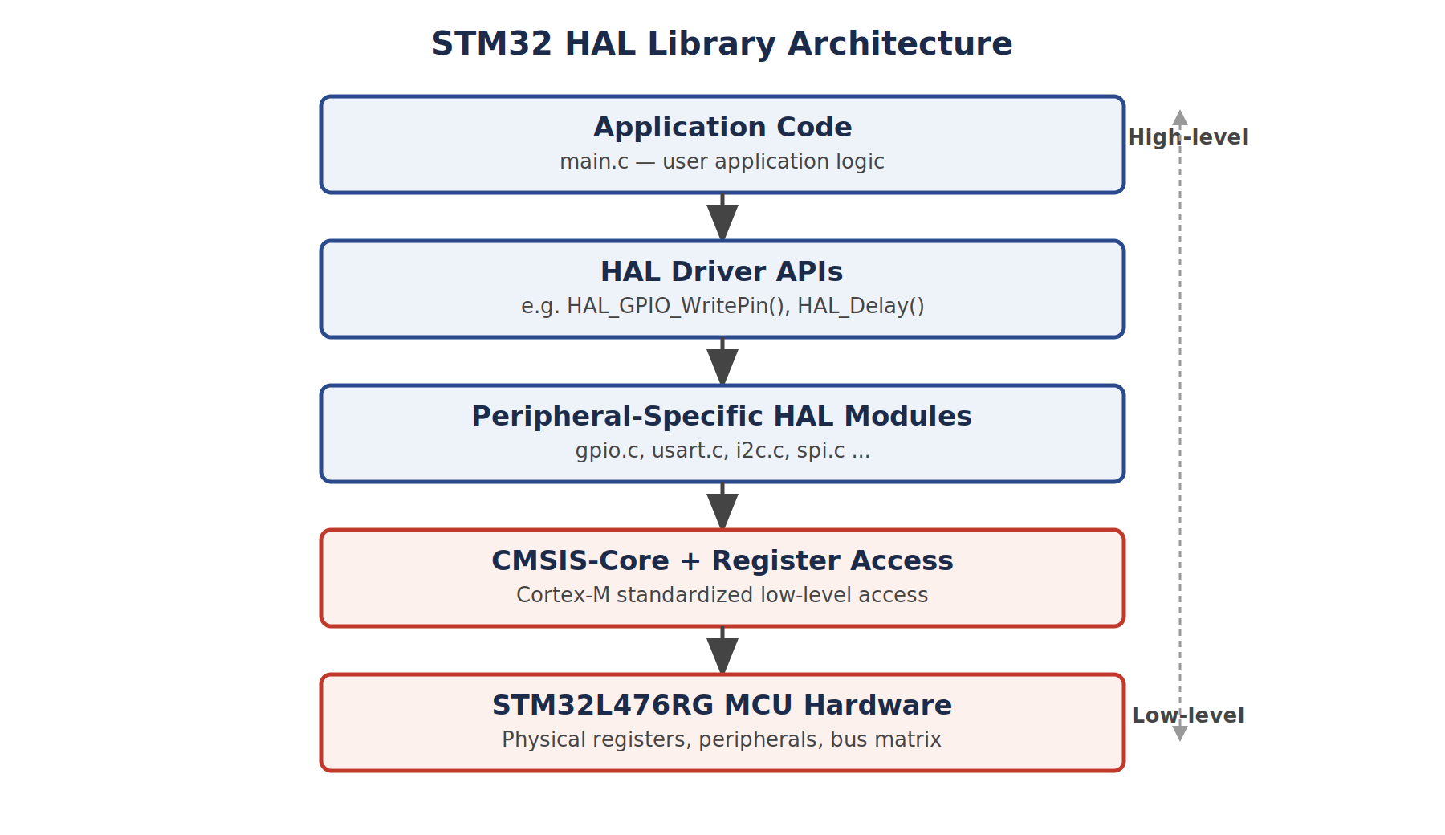
The application code only needs to interact with HAL APIs, while the HAL drivers internally take care of register-level programming. In traditional embedded programming, every peripheral configuration requires detailed manipulation of memory-mapped registers, which is complex, time-consuming, and varies widely among STM32 families. HAL eliminates this complexity by providing reusable and tested high-level APIs.

Procedure

A. Creating and Setting up a New Project
- Launch STM32CubeIDE.
- Go to File → New → STM32 Project.
- In the MCU/Board Selector, choose the STM32L476RG microcontroller (or the NUCLEO-L476RG board).
- Click Next, and give your project a name (e.g., Experiment1_HAL_GPIO_Blink).
- Ensure the Toolchain is selected as STM32CubeIDE and finish the wizard.

B. Configuring Peripherals (Using STM32CubeMX)
- In the Pinout & Configuration tab, locate and click PA5 (or any desired GPIO pin) and set it as GPIO_Output.
- Optionally, enable USART2 under connectivity for serial output (configure TX and RX).
- Navigate to the Clock Configuration tab and validate default settings. If needed, enable HSE or LSE depending on external crystal availability.
- In the Project Manager tab, set code generation settings and ensure HAL drivers are selected (not LL).
- Click on GENERATE CODE.

C. Understanding Generated Code Structure
Explore the following:
- main.c — Contains user code in main() function.
- gpio.c, gpio.h — Initialization and definition of GPIOs.
- stm32l4xx_hal_conf.h — HAL driver configuration header.
- system_stm32l4xx.c — System clock and startup functions.
- MX_GPIO_Init() — Called inside main.c to initialize GPIOs.

D. Editing Application Code
Inside main.c, in the while(1) loop, write:
while (1)
{
HAL_GPIO_WritePin(GPIOA, GPIO_PIN_5, GPIO_PIN_SET); // LED ON
HAL_Delay(500); // Delay for 500 ms

HAL_GPIO_WritePin(GPIOA, GPIO_PIN_5, GPIO_PIN_RESET); // LED OFF
HAL_Delay(500); // Delay for 500 ms
}

E. Build and Flash the Code
- Click on the hammer icon to build the project.
- Click on the bug icon to launch the debug session.
- The code will be flashed to the MCU via ST-Link.

F. Observation and Testing
On successful upload:
- The LED connected to PA5 should blink every 500 ms.

Result
The STM32CubeIDE environment was successfully explored and a GPIO peripheral was initialized using the HAL library on the STM32L476RG microcontroller. The project was configured using STM32CubeMX, HAL-based initialization code was generated automatically, and the application code was written, built, and flashed onto the board via ST-Link. On execution, the LED connected to PA5 turned ON and OFF at 500 ms intervals as controlled by HAL_GPIO_WritePin(), confirming correct GPIO output operation.

Conclusion

